I will explain you the whole concept of HashMap by putting**5 key-value pairs in HashMap.**  
  
***Initially,*** we have bucket of**capacity=4.**(all indexes of bucket i.e. 0,1,2,3 are pointing to null)

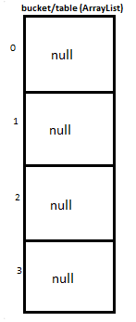

***Let’s put first key-value pair in HashMap-***  
**Key=21, value=12**  
**newEntry Object** will be formed like this >

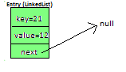

We will calculate hash by using our**hash(K key)**method **-**in this case it returns  
**key/capacity= 21%4= 1**.  
So, **1**will be the**index of bucket**on which **newEntry object** will be stored.  
We will go to **1st**index as it is pointing to null we will **put our newEntry object there**.  
  
  
At completion of this step, our HashMap will look like this-

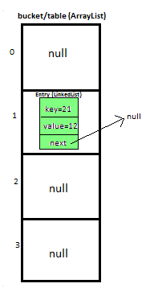

***Let’s put second key-value pair in HashMap-***  
**Key=25, value=121**  
**newEntry Object** will be formed like this >

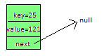

We will calculate hash by using our**hash(K key)** method - in this case it returns   
**key/capacity= 25%4= 1.**  
**So, 1** will be the**index of bucket** on which**newEntry object** will be stored.  
We will go to **1st**index, it contains **entry with key=21**, we will compare two keys(i.e. **compare 21 with 25**by using **equals method**), as **two keys are different** we check whether entry with key=21’s **next is null or not**, **if next is null** we will **put**our **newEntry object**on **next.**  
  
  
At completion of this step our HashMap will look like this-

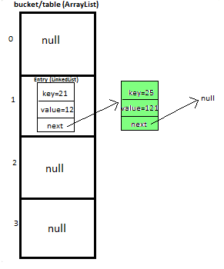

***Let’s put third key-value pair in HashMap-***  
**Key=30, value=151**  
**newEntry Object** will be formed like this >

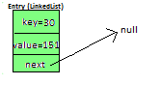

We will calculate hash by using our**hash(K key)**method **-**in this case it returns  
**key/capacity= 30%4= 2**.  
So, **2**will be the**index of bucket**on which **newEntry object**will be stored.  
We will go to **2nd**index as it is pointing to null we will **put our newEntry object there**.  
  
  
At completion of this step, our HashMap will look like this-

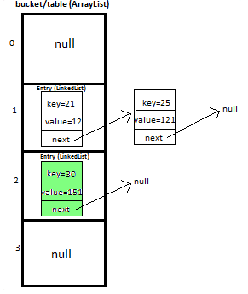

***Let’s put fourth key-value pair in HashMap-***  
**Key=33, value=15**  
Entry Object will be formed like this >

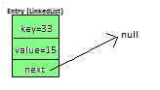

We will calculate hash by using our **hash(K key)**method - in this case it returns   
**key/capacity= 33%4= 1,**  
**So, 1** will be the**index of bucket** on which**newEntry object** will be stored.  
  
  
We will go to **1st**index -   
**>**it contains **entry with key=21**, we will**compare**two keys (i.e. **compare 21 with 33**by using **equals method**, as **two keys are different,**proceed to next  of **entry with key=21 (**proceed only if **next is not null).**  
**>**now, next contains **entry with key=25**, we will**compare**two keys (i.e. **compare 25 with 33**by using **equals method**, as **two keys are different,**now **next of entry with key=25** is pointing to **null**so we won’t proceed**further,**we will **put our newEntry object on next.**  
  
  
At completion of this step our HashMap will look like this-  
  
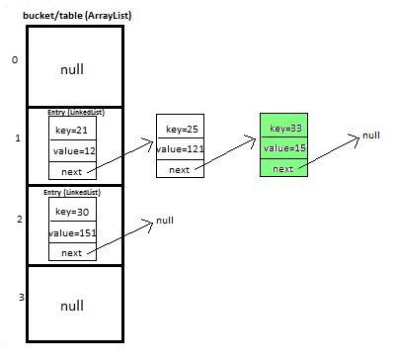

***Let’s put fifth key-value pair in HashMap-***  
**Key=35, value=89**  
  
  
**Repeat above mentioned steps.**  
  
  
At completion of this step our HashMap will look like this-

